# **For Publication Tab**

* All the selected papers of SUSTAINED 2024 will be published in **the proceedings of IEEE Xplore.**
* Selected extended versions of manuscripts will be published in **Scopus-indexed Journals** as follows.
* **Special Issue in International Journal of Energy for a Clean Environment**
* **Indian Journal of Environmental Protection**
* 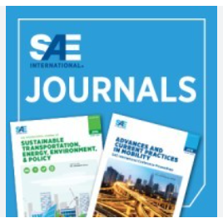**SAE International Journals**

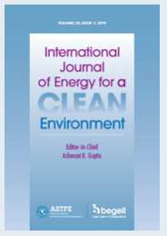

# **For Download Tab**

Paper Format

PPT Format

Program Schedule

Guidelines

Conference Brochure

# **For Contact Tab**



**Contact Us:**

Dr. Prateek Mittal, Mobile: 7838682667, Email: prateekmittal.set@mriu.edu.in

**Address**

Sector - 43, Manav Rachna International Institute of Research and Studies

Aravli Hills, Faridabad, 121003

Format as below

